**Fast Pass – Children’s Health Emergency Department**

**Children’s ER FAST PASS** 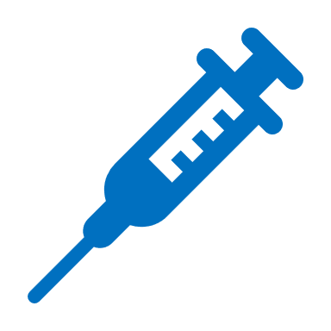

Hi, I have cancer and a fever.

1. Please put me in a room and give me antibiotics in my line as soon as possible.
2. I have a central venous catheter.
3. My port uses a 20 g needle: ¾”, 1”, or 1.5” (Parent or Guardian to confirm)
4. Please flush my port with 100 units of Heparin before de-accessing.

Thank you very much!