STUDENT INFORMATION
Last Name ___________________ First Name _____________________ Middle Initial ________
Current Address _________________________________________________________________________________
City ______________________________________________ State ___________ Zip _________
Permanent Address _________________________________________________________________________________
City __________________________________________ State ________________Zip _________
Phone Primary (___) _____________________ Secondary (____) ___________________________
School Email ___________________________________ Current employee? ______________ EIE# _________

EDUCATION

Current College or University _______________________________________________________

Major_______________________________________________________________________________
Degree _____________________________________________________________________________

Anticipated graduation date ____/____/_________

How many hours are you seeking to complete during this semester’s rotation? _______

What is your primary interest? (Chose up to three)
Orthopedics
Hospitalist
Primary Care
Complex Care
Pain Management
Pre-Anesthesia Assessment (Dallas)
Pre-Anesthesia Assessment (Plano)
Wound Ostomy (Dallas)’
Wound Ostomy (Plano)
Medical Screening Exams (MSE)
Palliative Care
Pulmonology (Plano and Prosper)
Other ____________________

List 3 Objectives you seek to gain from this clinical rotation.

- ______________________________________________________________________________
- ______________________________________________________________________________
- ______________________________________________________________________________

Have you had any exposure to the area(s) you requested and if so, what was the experience?
____________________________________________________________________________________
________________________________________________________________________________________________________________________________________________________________________

What qualities are you looking for in a preceptor? ____________________________________________________________________________________________________________________________________________________________________________________________________________________________________________________________

Have you previously done any rotations at Children’s? If so, with whom? ____________________________________________________________________________________________________________________________________________________________________________________________________________________________________________________________

Availability: Start date: ______________ End date: ___________________

Days available: Mon □ Tue □ Wed □ Thu □ Fri □

ADDITIONAL COMMENTS:

Program information

Eligibility
Only students with active facility agreements (between the school and CHST) will be considered. The candidate must be enrolled and in good standing in a fully accredited graduate program- Athletic Training, Kinesiology, Nurse Practitioner or Physician Assistant/Associate

If there is no current facility agreement, but the school is eligible- it takes approximately 3-6 months to complete.

**Schools need to have access to My Clinical Exchange platform for student onboarding

Application process
Candidates must complete an application form and submit with their cover letter, resume, and reference page. All application items must be submitted as a complete package. Incomplete applications will not be reviewed.

Please submit the following materials as part of your application package.
Resume: Attach a resume in which you list relevant coursework, work experience, and any other related experience for which you are applying.
Cover letter: Please express your intent and expectation for this internship.
Reference page: List at least 3 no more than 5 references.

Clearance Process:
If you are selected for a clinical rotation for your requested semester, please have your school enter your request into My Clinical Exchange for formal approval. There will be multiple forms that will need to be completed by both you and your school for final clearance. Clearance by Student Services is required prior to starting your clinical rotation.

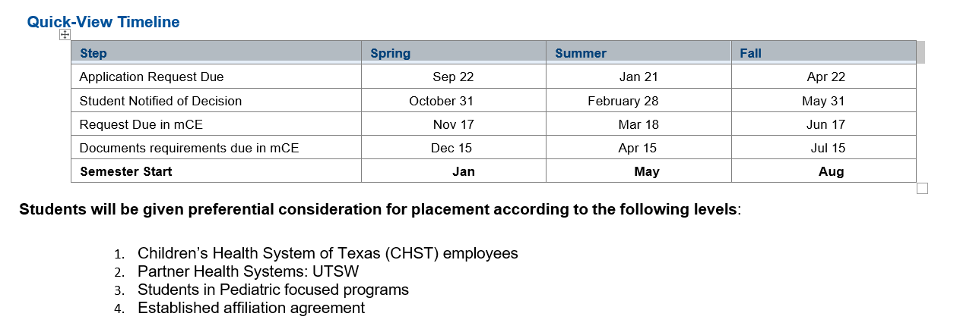

Contact:
Linda Grande DNP, APRN, CPNP-PC, RNFA
Director of Advanced Practice Services
AdvancedPracticeProviderPreceptorConnect@childrens.com
Cell: 214-695-6926

